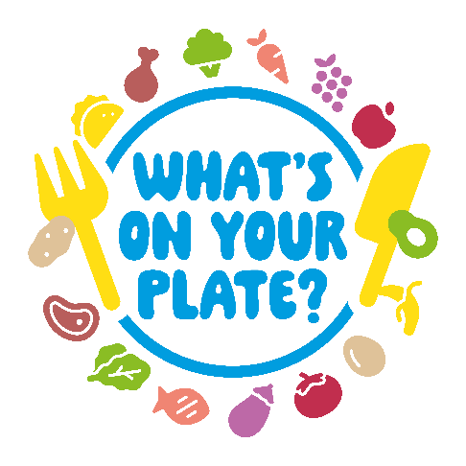
What’s On Your Plate?

Food affects your wellbeing. Having a balanced and varied diet helps you get everything your body needs to feel good and function well.
We know many people are worried about the current cost of living, with the price of food putting pressure on many families.
With this in mind we have launched the What’s On Your Plate? food support campaign, which aims to promote the help available in South Gloucestershire, as well as highlighting ways to save money, reduce food waste and support local businesses.

Main campaign messages
Getting enough to eat
We want to make sure everyone in South Gloucestershire has enough food to feed their family. We can help with emergency food payments, long-term support, applying for Free School Meals and our Holiday and Food Programme. We can also signpost to food support organisations.
Reduce food waste
You can save up to £60 a week by buying only what you need, storing food so it lasts longer, using up leftovers and reducing what you throw away.
Support local
Buying local produce doesn’t have to cost more especially if you shop smarter and use everything you purchase. Supporting independent, local traders like greengrocers and butchers helps your High Street thrive, puts money back into your community and reduces food mileage.
Sustainable food places
We are developing a food partnership across South Gloucestershire to reduce food poverty, improve access to healthy food to reduce food related ill-health, tackle loss of biodiversity, climate change and reduce the amount of food that is wasted.

Essential signposting
For guidance on what financial support is available and advice on local services visit our dedicated cost of living website at: www.southglos.gov.uk/costofliving
Residents can also call the council’s freephone helpline on 0800 953 7778 between 8.45am and 5pm Monday to Thursday and 8.45am to 4.30pm Friday.
Our One Stop Shops in Kingswood, Yate and Patchway are open Monday to Friday 9.00am-4.30pm
Community Welcome Spaces are open across South Gloucestershire providing a friendly welcome. Some offer free drinks, activities and facilities plus information on local financial support available and energy saving tips. To find a Community Welcome Space visit: www.southglos.gov.uk/community-welcome-spaces
South Gloucestershire libraries are always free to visit and host a variety of activities for children. Information can be found at: www.southglos.gov.uk/libraries
For information on free activities and days out, as well as signposting residents to help and support, please see suggested social media posts and images below.
Messages can also be shared from the council’s social media platforms:
Facebook: www.facebook.com/sgloscouncil
X (formerly Twitter): www.twitter.com/sgloscouncil

Getting enough to eat

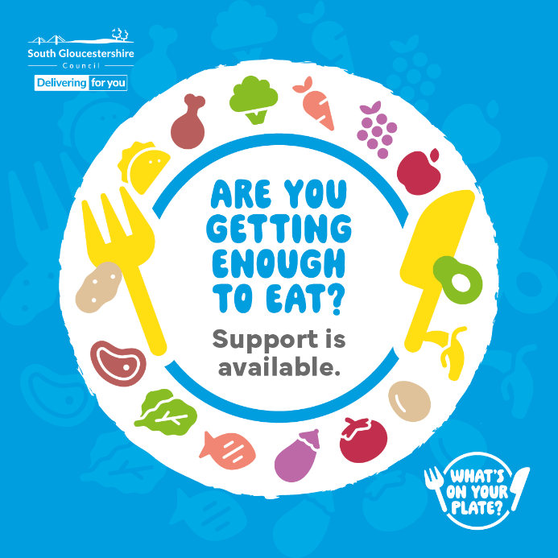

Text: Support is available to make sure you are getting enough to eat.
Find out if you’re eligible for:
Emergency food aid
Healthy Start vouchers
Free school meals and more
Visit www.southglos.gov.uk/costofliving for more information.
#CostOfLiving #WhatsOnYourPlate

Reduce food waste

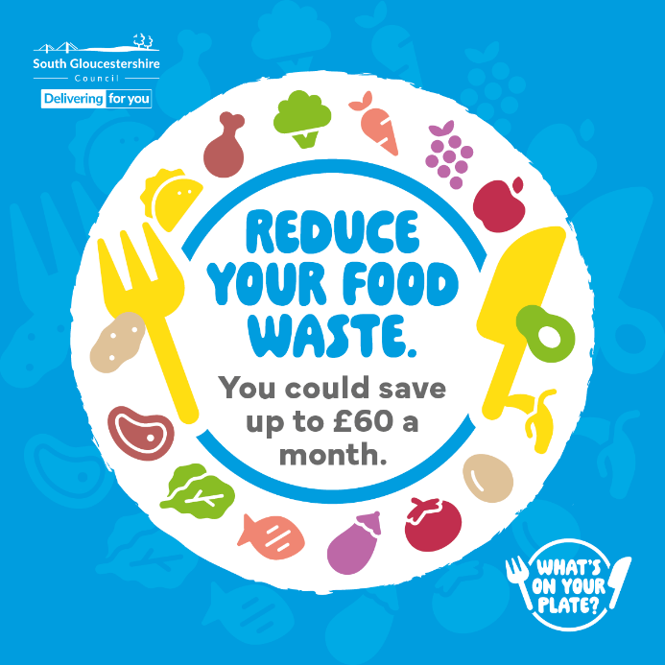

Text: Did you know reducing your food waste can save you up to £60 a month?
There are so many small changes you can make to the way you shop, cook and plan your meals that will reduce how much food you waste and save you money.
Find out more at: www.southglos.gov.uk/food-waste
#CostOfLiving #WhatsOnYourPlate

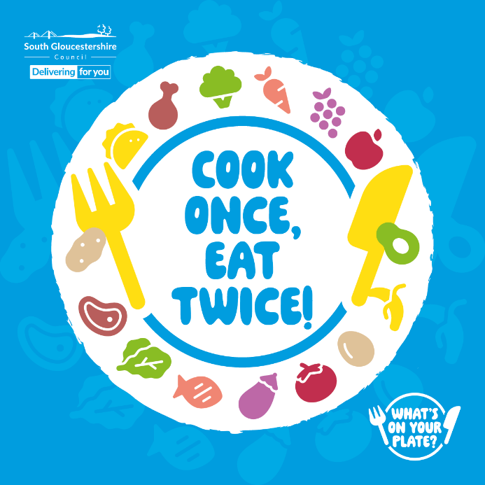

Text: There are many meals you can cook and enjoy the next day, saving time and money. It’s also a great way to reduce food waste.

Here are some ideas:

Cook once: Chicken stew
Eat twice: Chicken pie: Use the stew as a filling inside some ready-rolled pastry and bake into a delicious pie.

Cook once: Three-bean chilli
Eat twice: Chilli mac and cheese: Mix the chilli with pasta and top with cheese for a comforting dish.

Cook once: Sausage and vegetable traybake
Eat twice: Sausage and vegetable wraps: Load any leftovers into pitta breads or tortilla wraps and add salad.

Cook once: Ratatouille
Eat twice: Vegetable pasta bake: Mix leftover ratatouille with pasta, top with cheese and bake in the oven.

For more money-saving ideas visit: www.southglos.gov.uk/costofliving

#CostOfLiving #WhatsOnYourPlate

Support local

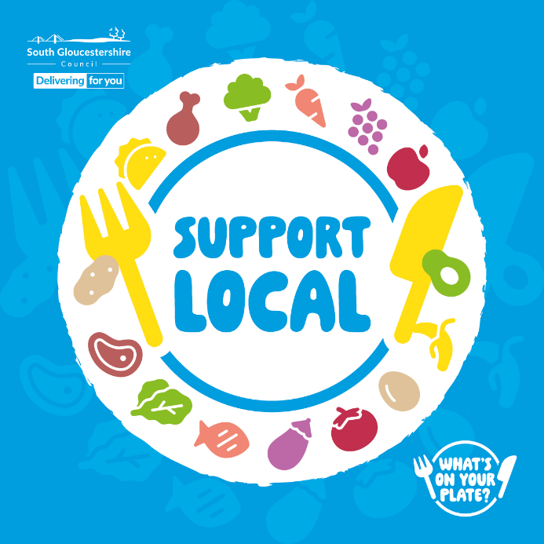

Text: Buying local produce doesn’t have to cost more, especially if you shop smarter and use everything you purchase.
Supporting independent, local traders like greengrocers and butchers helps your High Street thrive, puts money back into your community and reduces food mileage.
Find out more here: https://www.southglos.gov.uk/shop-local
#CostOfLiving #WhatsOnYourPlate

Sustainable food places

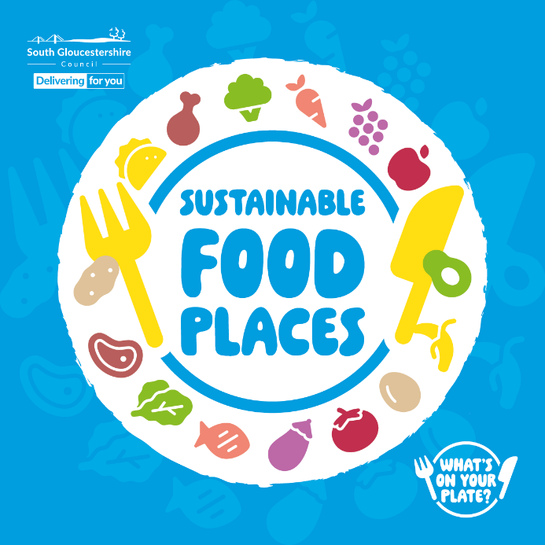

Text: We are developing a food partnership across South Gloucestershire to reduce food poverty, improve access to healthy food to reduce food related ill-health, tackle loss of biodiversity, climate change and reduce the amount of food that is wasted.
Find out more here: www.sustainablefoodplaces.org
#CostOfLiving #WhatsOnYourPlate

Free and fun activities to try

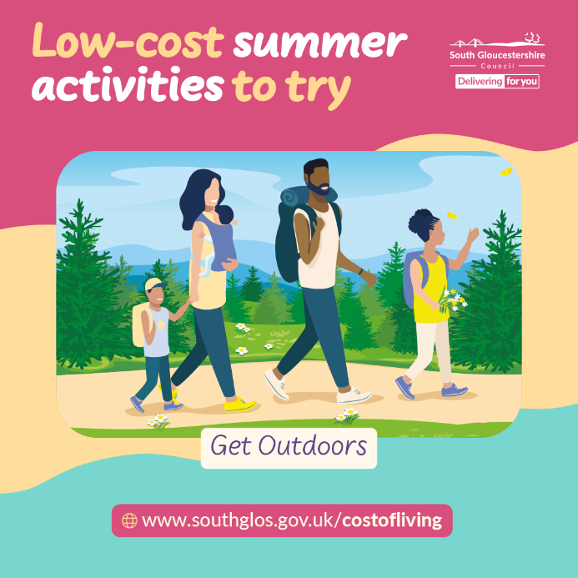

Text: It’s time to get outside!

The summer months provide the perfect opportunity to enjoy the great outdoors and South Gloucestershire has plenty of places to explore.

For day out inspiration visit: www.southglos.gov.uk/tourism

#CostOfLiving #SouthGlosSummer

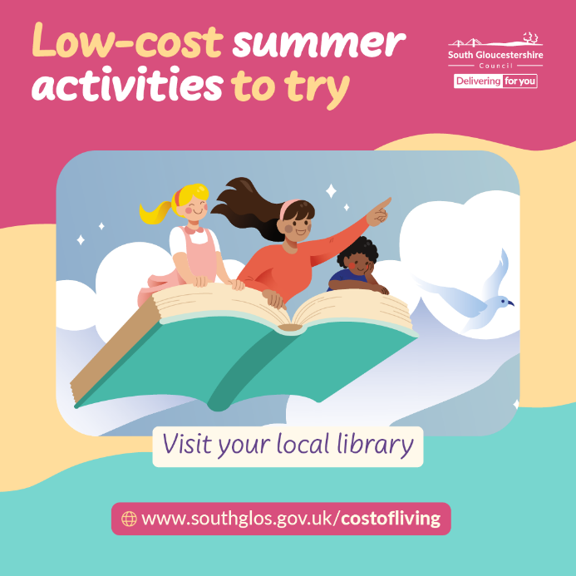

Text: Have you visited your local library recently?

There are lots of free, fun activities for families to enjoy at South Glos libraries during the summer holidays.

For more details visit: www.southglos.gov.uk/libraries

#CostOfLiving #SouthGlosSummer

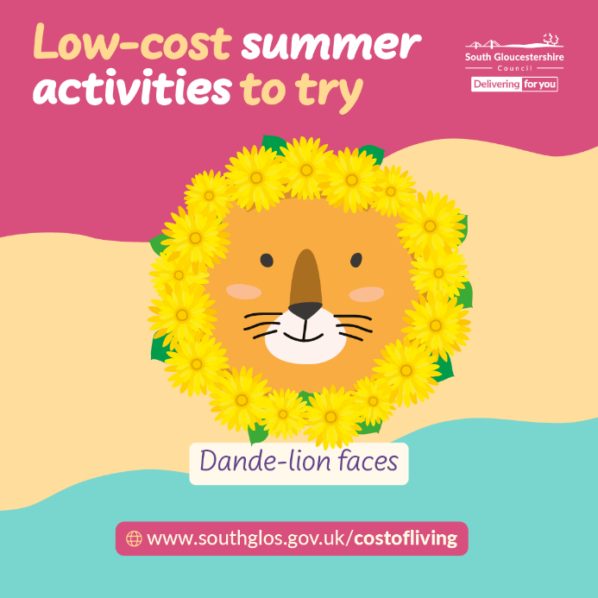

Text: In need of summer holiday activity inspiration? Why not make some dande-lion faces?

This craft idea is a great excuse to get outdoors and make the most of nature. Cut a circle out of some cardboard, draw a lion’s face, and collect as many dandelions as you can to make a nice, bushy mane. You can either glue the flowers onto your lion or make little holes in the cardboard and thread them through.

For more free activity ideas, visit: www.southglos.gov.uk/costofliving

#CostOfLiving #SouthGlosSummer

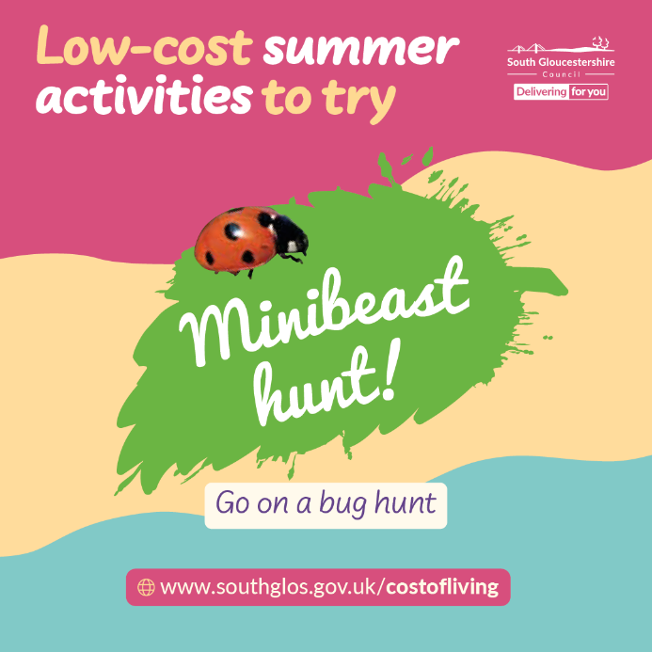

Text: We’re going on a bug hunt!

For an easy (and free) summer holiday activity, visit your local park and see what creepy-crawlies you can find.

You can download a minibeast hunt checklist here: www.woodlandtrust.org.uk/blog/2023/05/minibeast-hunt

#CostOfLiving #SouthGlosSummer

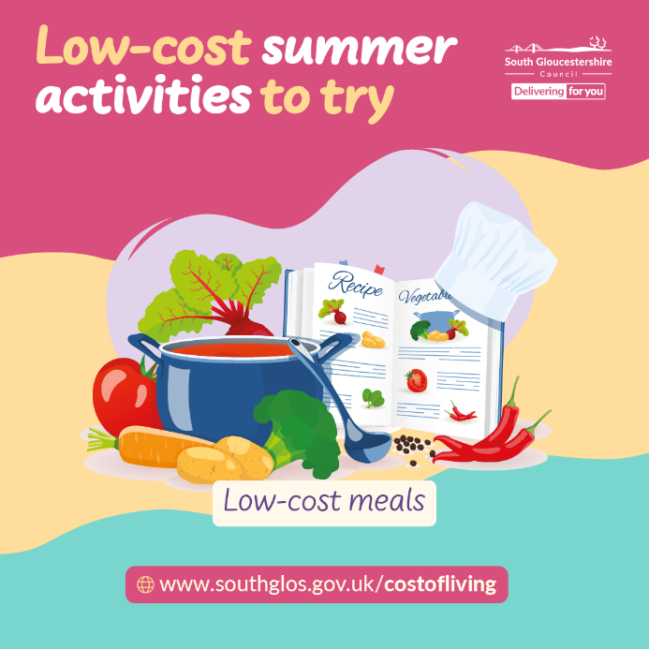

Text: Spending less money this summer doesn’t mean having less fun.

Many restaurants and supermarket cafes have free kids meals or ‘kids eat for £1’ deals on during the school holidays.

There are also lots of low-cost recipes online to try.

For more money saving tips and tricks, visit: www.southglos.gov.uk/costofliving

#CostOfLiving #SouthGlosSummer

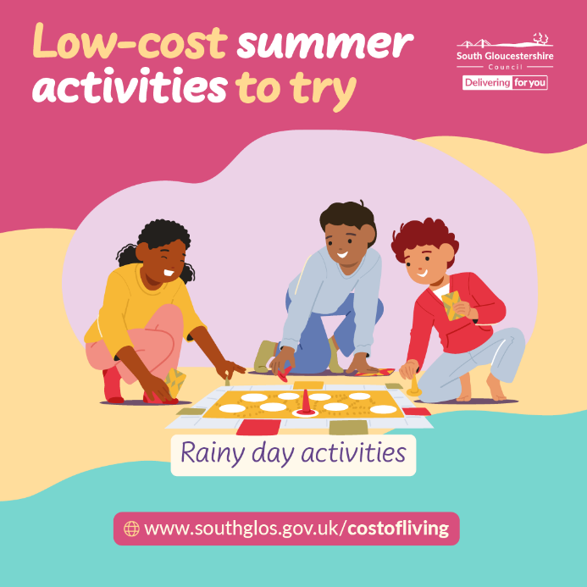

Text: If it’s raining, there are still lots of low-cost activities you can do during the school holidays.

You could:

Make a scrapbook
Host a board game challenge
Have an indoor treasure hunt
Create a family tree using old photographs

Or perhaps get outside and brave the rain - grab your wellies and get splashing!

For more free activity ideas, visit: www.southglos.gov.uk/costofliving
#CostOfLiving #SouthGlosSummer

General cost of living advice

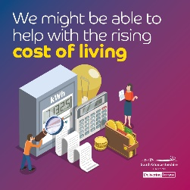

Text: Are you worried about the rising cost of living?
Don’t be afraid to ask for help if you are struggling to pay your bills. You may be entitled to extra government support or help from local services.
To find out what help is available, visit South Gloucestershire Council’s dedicated cost of living page at: www.southglos.gov.uk/costofliving
You can also call the council’s freephone helpline on 0800 953 7778 or visit a One Stop Shop in Kingswood, Patchway or Yate.
#CostOfLiving

Community Welcome Spaces

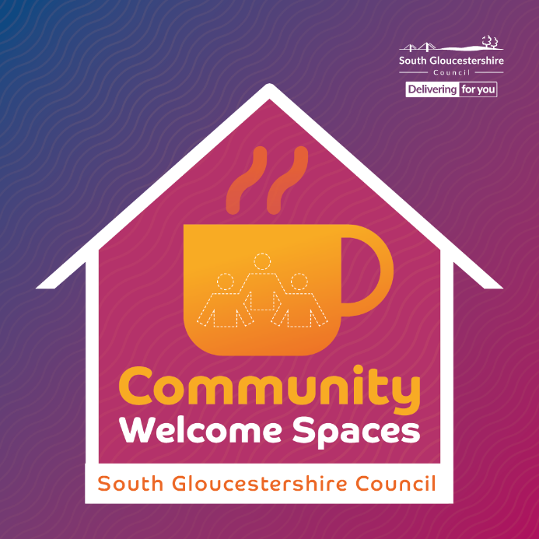

Text: Community Welcome Spaces across South Gloucestershire offer a warm, friendly welcome and are free to use.
Some offer free drinks, activities and facilities plus information on local financial support available, energy saving tips and government cost of living help.
Find a welcome space here: www.southglos.gov.uk/community-welcome-spaces
#CostOfLiving #CommunityWelcomeSpaces

Contact information
Chantelle MacGowan
Communications Officer
Strategic Communications
Chantelle.Macgowan@southglos.gov.uk
www.southglos.gov.uk

