Going Back to School

Instead of coming to school I have been doing my learning at home. I did this because we were trying to stop Coronavirus from spreading really quickly – this is called a ‘lockdown’ or ‘self-isolation’.

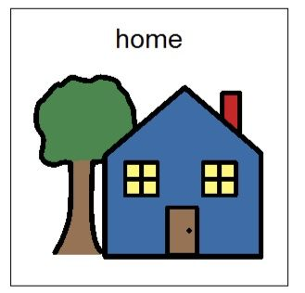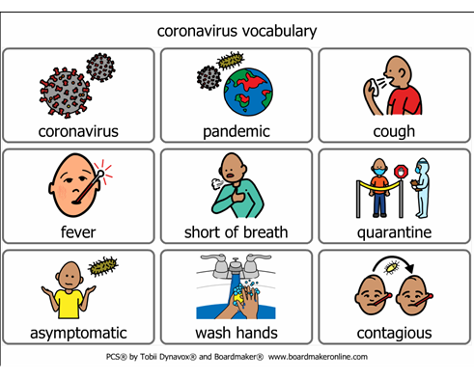

The scientists have told us we have done a good job in slowing down the spread of Coronavirus by following the rules during the ‘lockdown’ and now I can go back to school to do my learning.


It will be good to see my friends and my teachers again.

Coronavirus has not gone away it is just spreading more slowly so I still need to be careful, follow the rules and remember to:
- Wash my hands when I come into school, after play, before and after eating and before I go home.
- Not stand too close to people – give them a lot of ‘hula hoop’ space.
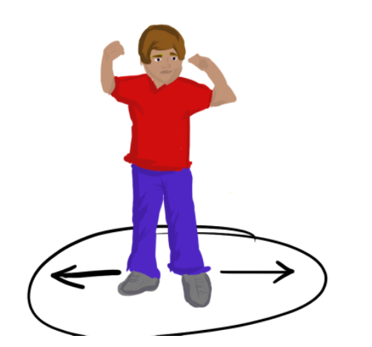
- Cough and sneeze into my elbow.
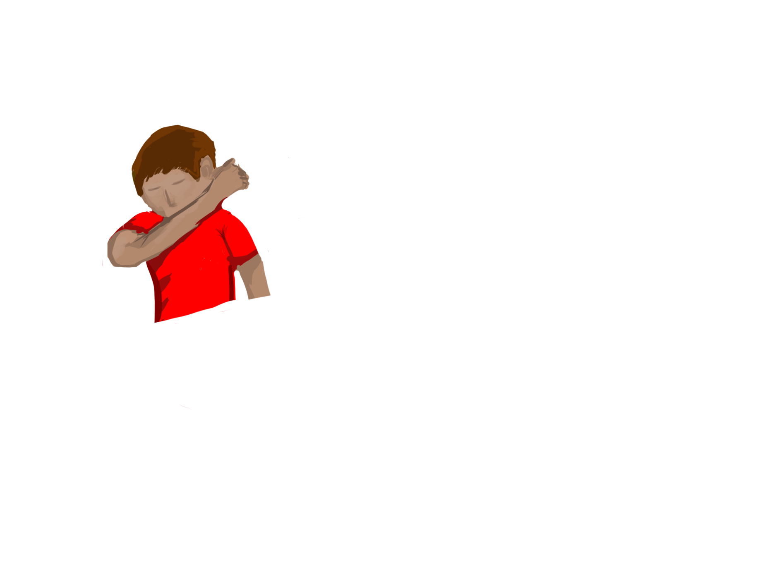
- Wipe my nose with a tissue then put it in the bin and wash my hands.
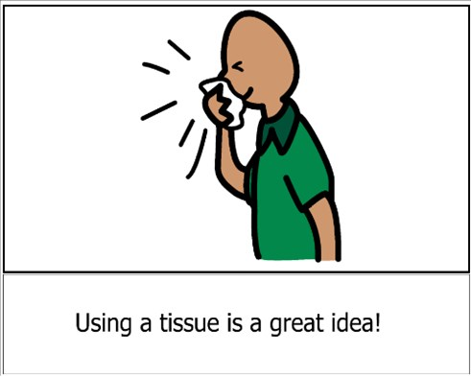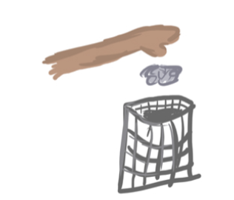

To keep me extra safe Mr Botten has devised a plan.
- I will meet Miss Deacon, Mrs Wilson or Mrs Abbott at the school reception door at 9.20am. I will walk into school with them and Mummy will stay outside.
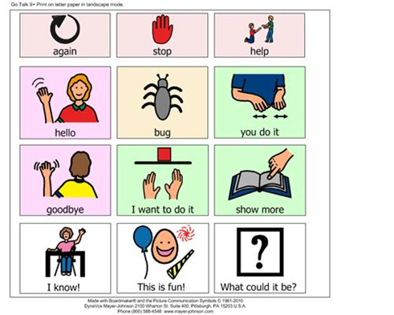
- I will wave goodbye to Mummy and give her a kiss and then walk into school and down the corridor with my teacher, holding her hand.

- I will have my temperature taken to make sure I do not have a fever. My teacher will use a scanner thermometer on my forehead not in my ear.

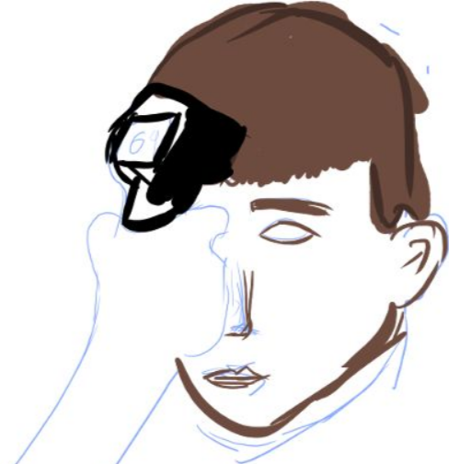

- My teacher and I will have gel squirted on our hands when we get into school.
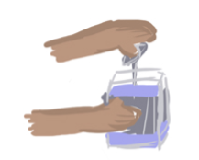

- I will wash my hands when I get to my classroom.

- I will not be in Birch class – I will be in Elder Class (Year 2) and Mrs Wilson and Ms Deacon will be my teachers. Mrs Abbott will also be in my class.
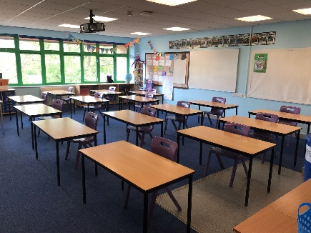

My class will have fewer children – it will be called a ‘class family’ and I will do my learning and play with my ‘class family’.
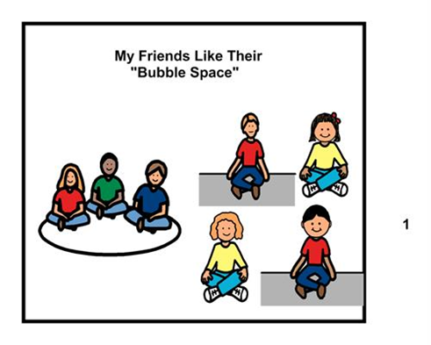

- I will not be able to learn and play with the other class families.

If I need a break I can ask to go outside with an adult.

If anyone in my class family becomes ill at school, the whole ‘class family’ will be sent home for a little while so we can make sure the virus does not spread to other ‘class families’. After a few days I can come back to school and be with my ‘class family’ again.

Remember that most children are unaffected by Coronavirus – this is called ‘asymptomatic’ – so I may not even feel ill.

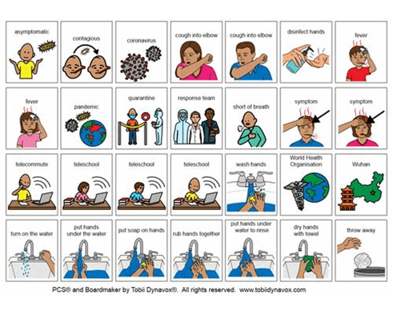

It will be good to be back in school with some of my friends and my teachers.

I will not be in school all day. Mummy will pick me up from outside the school reception – my teacher will take me to her at 10:20am and I will go home with Mummy.

