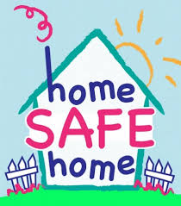
Staying Safe


The Coronavirus is very contagious. This means it can spread between people very easily.

Just like any other cold or flu Coronavirus will go away in a couple of months.

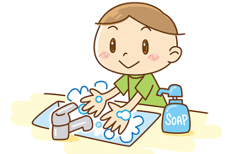
I can help stop the spread of germs by washing my hands with soap and water.


I can take my time when I wash my hands, making sure I wash between my fingers and all over my hands


My ________ is showing signs of the Coronavirus. The Doctor has told them to self-isolate for 14days. This will help stop the spread of the virus to other people. It will help him get better


This means they cannot meet other people outside the house.


_______ wants to keep me safe too. They are doing this by not being very close to me. This is ok. They still love me. _____ wants to keep me healthy.



I can help by listening to what he is telling me.

Dad will use the no symbol to let me know if I can or cannot go into the room. If the symbol is not on the door I can go into the room, but if dad puts the symbol on the door I cannot go into the room.
This is to keep me safe and healthy


They will need more space. I can do this by not sitting beside them





I should try not to hug / kiss them. Instead I can wave.

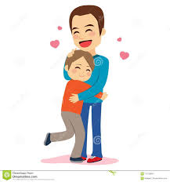
This will not last forever and I will be able to hug and kiss them again soon.

While they are in self-isolation, I can help by keeping myself busy.

I can…………….
Do my schoolwork
Watch TV

Play my PlayStation/Xbox
Play with my toys
_________________________________________________________________________________________________________________________________

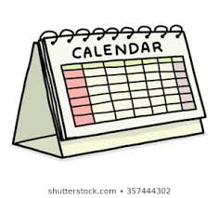
We will use a calendar to help me see how long this will last


Once they are allowed out of self-isolation, we can do the things we use to do together.


They will be so happy that I listened to them to help keep myself safe.

