
Going Shopping: Remember the Rules

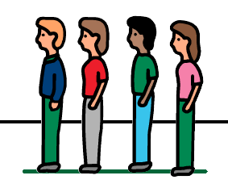 | I will now need to queue outside the shop before I can enter
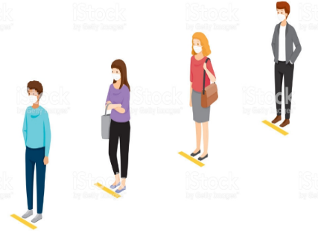 | I will stand on the spot/line and move forward when the person in front of me has moved
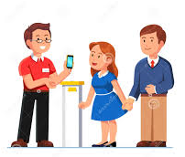 | The shop assistant will tell me when I can enter the shop
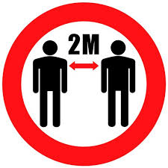 | I will keep my 2metres social distance from people who do not live in my house
 | I will follow the arrows in the shop which tell me what direction to go
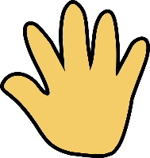 | I will try to not touch items unless I am going to buy them
 | When I am ready to pay, I will stand on the lines/spots at the till and wait until the shop assistant tells me to move forward
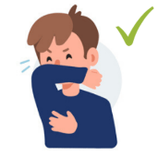  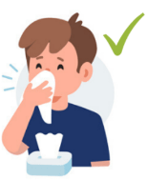 | If I need to sneeze or cough, I will do this into my elbow or tissue and then wash my hands
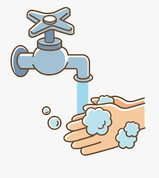 | I will wash my hands when I return home for 20 seconds, this will keep me and my family safe

