Arrangements for Home Learning
Dear Parents
We have been expecting an announcement regarding school closures for a few days and this has given us the opportunity to create plans to ensure that your child can continue to work from home whilst schools are closed. Below are some answers to your questions:

Does my child have to work at home?
Yes. This closure could last some time and if your child does no work in this period, they will be seriously behind their peers when they return. Children also need routine, so setting a daily expectation of school work will help them keep a shape to their day which will be essential for their emotional well-being.

How will I know what my child must do?
Your child’s class teachers (or team of teachers for that year group) will email you directly every week to explain what learning your child needs to complete. The first of these emails will be sent out by 3:30pm on Monday 23rd March and then by 9:30am every Monday morning.
You will also be able to access this information by looking at the class pages on the school website: https://www.blackhorseprimary.org.uk/class-pages/

Do I need to sit with my child when they are working?
Obviously, if you can help your child with some of their work then please do. However, we know that many parents will also be working from home, running the house, looking after younger children, so we have designed most of the home learning to not require direct adult input.
Where should my child work?
Somewhere quiet, ideally at a table. Make sure the TV is off.
What resources will my child bring home?
Over the next two days your child will bring home the following:
- A ‘Maths No Problem’ Workbook.
- Five Reading Scheme books (and a longer book for children in Y3-6).
- An exercise book to write in.
My child has been off school this week – how will they get their home learning pack?
You can either collect this from school on Monday (please ring) or if you are still in isolation we will bring this round to your house.

What learning will my child be able to access online?
Your child will also be expected to complete some learning online for a short amount of time each day, all of which can be viewed on Smart Phones or Tablets. The online learning use will include:
- Daily Times Table Rock Stars Practice (Y2-6).
- Daily Numbots Practice (YR-Y2)
- Bug Club online books (these are digital versions of all our reading scheme books with online comprehension activities), YR-Y2.
What if my child can’t access a computer?
Most of the digital learning activities can be completed on a Smart Phone if necessary and the weekly learning plan doesn’t rely on your child having constant access to a computer. Most of the learning is traditional pencil and paper, although your child might need to access the internet to see tutorial videos etc.
I’m not a teacher – how will I know what to do?
We aim to make the home learning as easy as possible for parents (including sending home the answers to maths activities etc!). Children may also be completing activities which you may not fully understand so we aim to provide tutorial videos where something needs explaining. These will be hosted on the school website’s ‘Video Resource Centre’ and every year group has its own ‘channel’ (called a ‘playlist). https://blackhorse-ps.primarysite.media/
Mr Botten has put a video on the site already to get you started which you can view here.
What will my child’s weekly home learning timetable look like?
So that you know what learning your child should be doing each day, we will send you a weekly home learning timetable which will look like this example (although fully filled in!):
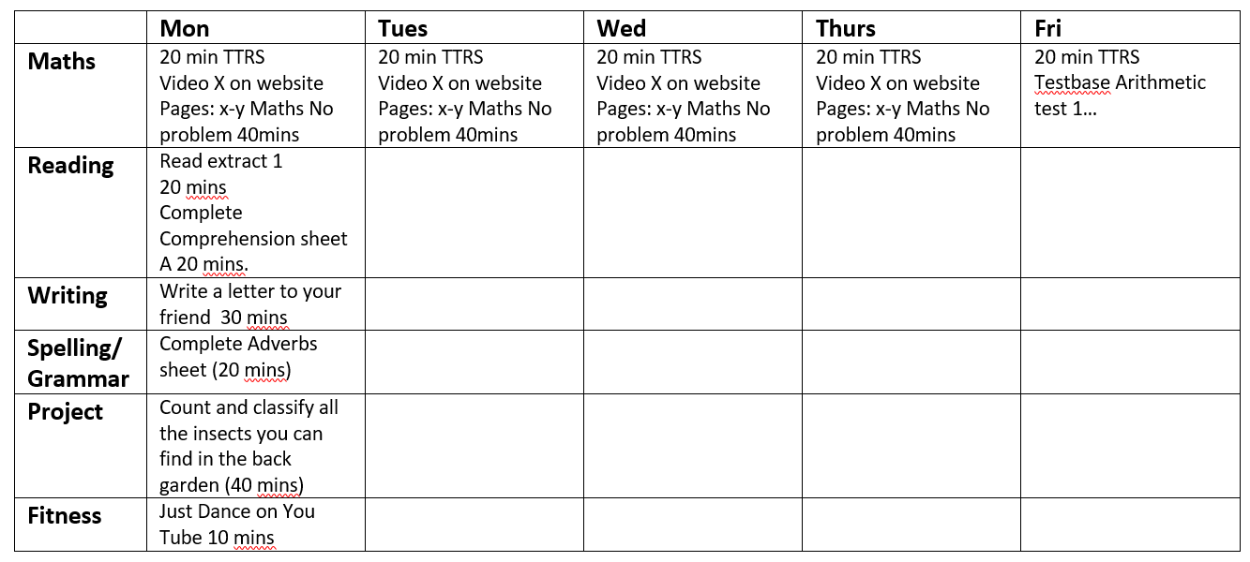

How do I know how much work my child must do each day?
We will specify next to each task how long your child should spend on it. However, as a guide, this is what will be expected:
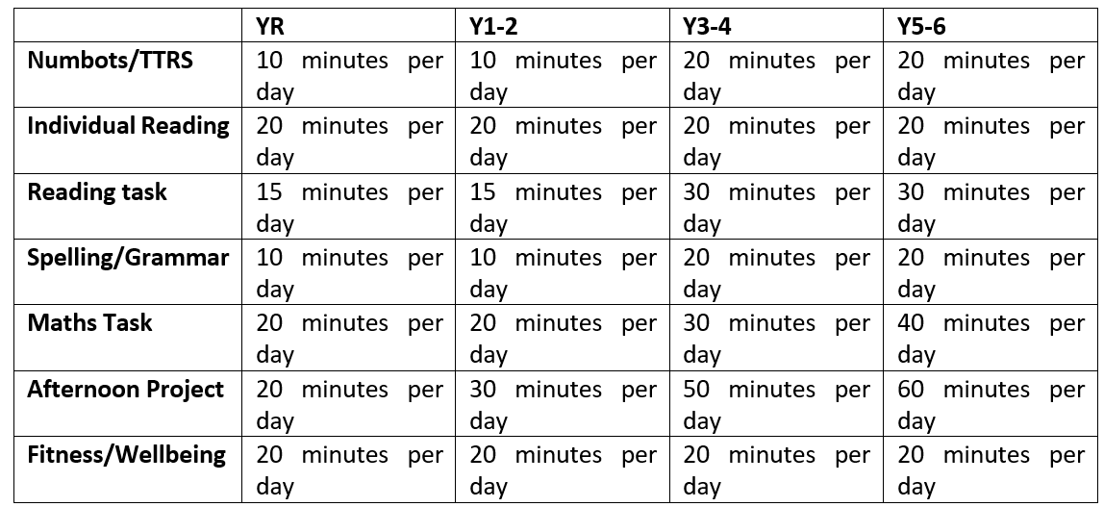
What if we get ill?
Your child does not need to complete the home learning if they are ill.
What about the Easter holiday?
Again, they will only need to read during the Easter holiday. Reading is the most important thing.
What if I’m an ‘Essential Worker’, my child has a Social Worker or an EHCP?
If you think you are in one of these categories, then your child may be able to continue attending school as normal. We are awaiting details from the government and will let you know as soon as possible how this will be organised.
My child gets Free School Meals and I am worried about the cost of feeding my family during this closure. Can the school help?
Quite possibly. We are awaiting information from the government about whether we will be able to help out with the cost of food. We will provide more information once we have it.
How do I contact the school?
Your child’s teacher (or someone from their year group team if they are ill) will email you every week. This means you will have their email address so that you can contact them directly.
If you have any larger worries, you can email me directly: simon.botten@blackhorsepri.org.uk
If you have anything our Family Link, Emma, can help with (parenting, housing, finance, general worries), you can contact her directly: Emma.Touzalin@blackhorsepri.org.uk
If you want to chat to our school counsellor about well-being or mental health issues, you can contact her directly here: sara.alhadeff@blackhorsepri.org.uk
If you have any questions about SEND or Resource Base, you can Email Jacqui directly here: jacqui.taylor@blackhorsepri.org.uk
The school office can be contacted here: office@blackhorsepri.org.uk
Emails will only be responded to during school hours (9am – 3:30pm).
We will be here for your children and yourselves throughout this difficult time. Keep them learning, keep a routine and contact us if you need to.

