BLACKHORSE PRIMARY SCHOOL
Severe Behaviour Policy

Author/Person Responsible | Head Teacher
Date of Ratification | Nov 2022
Review Group | Standards & Inclusion Committee
Ratification Group | Full Governing Body (FGB)
Review Frequency | Annual  Subject to local education authority and/or national policy change
Review Date | Nov 2023
Previous Review Amendments/Notes | September 2022  September 2021  May 2019  Dec 2019 – Re-write  May 2018  July 2010  July 2011  July 2012  Oct 2014 – Significant Update
Related Policies | Positive Handling Policy  Good Behaviour Policy  Anti-bullying Policy  SEND Policy  Equalities and Diversity policy  Accessibility plan

Equality Impact Assessment (EIA)Part 1: EIA Screening
Policies, Procedures or Practices: | Severe Behaviour Policy | DATE: | October 2014
EIA CARRIED OUT BY: | S Botten | EIA APPROVED BY: | S Botten
Groups that may be affected:
Are there concerns that the policy could have a different impact on any of the following groups? (please tick the relevant boxes) | Existing or potential adverse impact | Existing or potential for a positive impact
Age (young people, the elderly; issues surrounding protection and welfare, recruitment, training, pay, promotion) |  | N/A
Disability (physical and mental disability, learning difficulties; issues surrounding access to buildings, curriculum and communication) | Due regard will be given to whether inappropriate behaviour is a result of a medical condition.
Gender reassignment (transsexual) |  | N/A
Marriage and civil partnership |  | N/A
Pregnancy and maternity |  | N/A
Racial groups (consider: language, culture, ethnicity including gypsy/traveller groups and asylum seekers) |  | N/A
Religion or belief (practices of worship, religious or cultural observance, including non-belief) |  | N/A
Sex (male, female) |  | N/A
Sexual orientation (gay, lesbian, bisexual; actual or perceived) |  | N/A
PART 1 – POLICY CONTEXT
- Introduction
  - The Blackhorse Primary School Positive Behaviour Policy is intended to encourage children to make positive choices and, through appropriate rewards and sanctions and the involvement of parents, provide a framework for children to learn self-discipline and respect. However, there are some occasions when it is necessary to apply the severe clause that is indicated in the policy. This policy explains the structure and processes of the severe clause, which, like the 'mainstream' policy, must be applied consistently.
- Definition of 'Severe Behaviour'
2.1 The following inappropriate behaviour can be classed as 'severe' and would therefore warrant the sanctions of the Severe Clause:
- Hate speech (racist, homophobic/ transphobic etc).
- Dangerous behaviour (e.g. violence, running away, being beyond the control of a member of staff, deliberately ignoring instructions, deliberately dangerous activities).
- Deliberately damaging property/ vandalism.
- Bullying, that is the repeated physical or verbal abuse to victim(s) by person(s) that continues following the implementation of the Anti-bullying policy and procedures.
- Violence towards staff.
- Persistent disobedience or destructive behaviour.
- Deliberately bringing items which could endanger others onto the school campus.
3. Severe behaviour resulting from SEND
3.1 This policy applies to all children at Blackhorse Primary School, however is likely that many severe behaviours are the result of a specific Special Educational Need or Disability (SEND) or Social Emotional Mental Health (SEMH) need.
3.2 Where this is the case, staff will attempt to improve these severe behaviours by addressing the SEND needs of the child e.g. by adapting the curriculum, reducing stress factors, identifying triggers, creating bespoke behaviour plans & staff risk-assessments etc.
3.3 The school will make every effort to reduce SEND suspensions through tailored and bespoke provision addressing need and through consultation with appropriate external/specialist agencies at the earliest opportunity.
3.4 The school retains the right to exclude a SEND child where allowing them to remain in school would seriously harm the education or welfare of the pupil or others in the school.

PART 2: GRADUATED RESPONSE TO SEVERE BEHAVIOUR
4.0 Pre-Planning & Risk Assessing.
4.01 Where a child joins the school with a known additional needs which potentially may result in challenging behaviours, a risk assessment in the form of a ‘Positive Behaviour Plan’ should be completed by staff working with the child, in conjunction with the SENCO/ Inclusion Leader.
4.02 The Positive Behaviour Plan will include details relating to behaviours exhibited, helpful strategies and unhelpful strategies (See Appendix 1).
4.03 Pre-planning allows needs to be identified and clear strategies agreed prior to any challenging or escalating behaviours taking place and should be shared with all staff and parents to ensure a common, consistent approach.

4.1 Stage 1 - First Incident
4.11. The Headteacher or other senior staff, together with Team Teach trained staff, if necessary, act to ensure that children and adults are, in the first instance, safe from harm. Staff will always attempt de-escalating strategies (including Emotion Coaching/ Thrive/ Team Teach language) as a first response to severe behaviour where the child or other children are not at risk of harm.
4.12 Where the child is at risk of harm to themselves or others, e.g. if a child is acting violently, refusing to comply with instructions intended to keep them safe or is damaging property, Team Teach trained staff may use agreed positive handling techniques to take the child to a safe place where they can calm down (Resource Base Ball Pool, Library, SENCOs office etc). See Positive Handling Policy.
4.13. If positive handling has been necessary, this will be recorded in the ‘Bound and Numbered Book’ as soon as possible after the incident.
4.14 The Head teacher will investigate by talking to all those involved in the incident including those impacted, possible perpetrator(s) and observers.
4.15. The Head teacher or other staff involved will record the incident on CPOMs.
4.16 The child will receive a sanction which is proportionate and appropriate to the severe behaviour exhibited and will take into account any additional needs. However, there must be an appropriate sanction and opportunity for restorative dialogue and reflection.
4.17 Children with specific Behaviour plans will have sanctions adapted to match those agreed in the plan.
4.18 The Headteacher will inform the parents/carers of the victim(s) and perpetrator(s). This will usually be done by telephone and recorded as an action on CPOMs.
4.19 Parents will be invited to discuss the incident with the Headteacher and/or class teacher.
4.20 Parents will be informed that any repetition of the behaviour may result in the child going ‘on report’ or having an Individual Behaviour Plan.
4.21 Those impacted by the severe behaviour of another child will be offered the opportunity to discuss the incident and may be counselled by appropriate member of staff if necessary, and with parental knowledge and consent.
4.22 Staff will be made aware of the incident and asked to monitor those involved at the weekly staff meeting.
4.2 Stage 2 - Second Incident.
4.21 Where the behaviours are deemed to be the result of an unmet need, the SENCO/ Inclusion Leader will complete assessments and observations of the child and will create an Individual Behaviour Plan and/or Behaviour Support Plan which addresses both the unmet needs and provide staff with clear guidance on how to manage associated behaviours. Support from external agencies should be sought at the earliest opportunity where behaviour may be linked to unmet needs.
Where the behaviours are not believed to relate to an unmet need, then the following steps will be taken:
4.22. Parents will be informed that the child is receiving daily monitoring for a specified period (usually between 4-6 weeks).
4.23. The child is issued with a daily monitoring card on which positive behaviour is recorded, which is to be presented to the member of staff responsible for him/her at the end of each session, break time, lunch, for a comment and a signature.
4.24. At the end of a given period (day/week), the child must take the card to the Headteacher for comment and signature
4.25 Child’s needs will be discussed with SENCO/ Family Counsellor and parents will be offered support, and the completion of a EHAP considered.
4.26 Thrive assessment will be completed by class teacher and passed to SENCO/ Family Counsellor.
4.27. Parents/carers may be informed that further behaviour of a similar nature may result in a Head teacher’s suspension for a day(s) duration up to a maximum of 15 days
4.28 Child will be placed on the school’s Safeguarding ‘Cause for Concern’ list and will be discussed at Safeguarding Team Meetings.
4.3 Stage 3 - Third Incident/ Pattern of dangerous behaviours emerging.
4.31 Where a single incident of severe behaviour is judged to have put staff or pupils in significant danger or have caused harm (including deliberately hurting a member of staff) then the school may move straight to Stage 3 for a first incident.
4.31. As the behaviours demonstrated continue to jeopardise the educational/ social outcomes for the child/ their peers, the child will be issued with an Individual Behaviour Plan (IBP) if this has not been completed during an earlier stage. This will be written in consultation with the class teacher, parent, child and Inclusion Leader/ SENCO. Parents will be given a copy of this policy and the action plan.
4.32 If not completed already, parents may be asked to complete a EHAP with the SENCO or Family Counsellor to explore issues and plan interventions.
4.33 If the child reaches Stage 3 as a result of a single serious incident, the child will be excluded from school for between 1-15 days (usually no more than 5 days), in accordance with LA and DFE regulations (see Exclusion Policy – Part 3). Fixed-term exclusions will usually be short (1-3 days) for first serious incidents.
4.34 The school takes a zero-tolerance approach to violence towards staff and, where a child has deliberately hurt a member of staff, then they will automatically receive a suspension.
4.35. By now the Special Needs Code of Practice will have been implemented and it is probable that the child will have a Behaviour Action Plan (if not this will begin at this stage).
4.36 Referrals will be made to external agencies e.g. Educational Psychologist or Behaviour Support Team if this has not already occurred. The SENCO and Headteacher will complete the ‘Alternatives to Exclusion Primary Checklist’ to ensure that all support options are being considered.
4.37. If there is a risk of immanent escalation which could lead to further exclusions, a ‘Team around the child’ (TAC) meeting will be arranged where all relevant agencies will be invited to share information and discuss possible strategies to improve outcomes.
4.38. Where the child is demonstrating increasingly volatile behaviour which is likely to result in further suspension, staff will be asked to complete ABC (Antecedent, Behaviour, Consequence) Chart to establish a pattern of behaviour. The Behaviour Support Team will be contacted and a new Behaviour Support Plan written, using specialist advice if necessary. It is likely that several Behaviour Support Plans (BSPs) will be needed before fully effective strategies are established so BSPs should be reviewed regularly.

4.4 Stage 4 - Fourth Incident/ increasing frequency of dangerous behaviours.

4.41 When this stage is reached, the child’s behaviour is presenting serious challenges to their own safety or educational development, that of their peers or the health and safety of school staff. At this point the child is at immanent risk of permanent exclusion.
4.42 As it is highly likely that behaviours are the result of unmet SEND needs, consideration should be made to whether:
- An EHCP needs assessment has begun or is ongoing;
- All reasonable adjustments have already been made;
- The school can safely meet the needs of the child within the current setting.
4.43 Having made all reasonable adjustments, should serious behaviour incidents continue:
- The Pupil will receive a further suspension of between 1-15 days.

- Any exclusion longer than 5 days will involve the school organising alternative provision either within another local school or via a recognised private provider.

- Upon return, the child, parent and Head teacher will meet to agree a behaviour contract aimed at identifying the critical behaviours being demonstrated and strategies for avoiding them.

- Another Team Around the Child (TAC) meeting will be held with relevant agencies and the LA to discuss ways to avoid a Permanent Exclusion.

- Parents will be informed, in writing, that a further serious incident could lead to Permanent Exclusion.

- The Headteacher/ Inclusion Leader will refer the child’s needs/ presentation to the LA Primary High Risk Group for multi-agency review.

4.5 Stage 5 – Subsequent Offences of a Similar Nature
4.51 Subsequent offences, which are not resolved by the actions taken above and which clearly put staff and/or children at risk of constant mental or physical harm, or the buildings and equipment of destruction or damage cannot be sustained.
4.52 By this stage, all other school-based options will have been exhausted and the school will contact the LA to consult with them as to options to avoid formal exclusion. Part 3 of this policy will then be followed.

PART 3: Exclusion Policy
  - All pupils benefit when behaviour is good. High standards of behaviour are important to help children feel safe and learn well. Parents and carers play an important part in this.
  - The government advises schools to focus on promoting positive behaviour, helping to build self-discipline and encouraging respect for others. Schools also need sanctions to deter pupils from misbehaving. This policy should be read in conjunction with our Behaviour Policies, SEND/Inclusion Policy and Single Equalities Policy.
  - The decision to exclude a pupil, either permanently or for a fixed period of time, will
therefore only be taken as a last resort and:
- In response to serious or persistent breaches of the school’s/academy’s Behaviour Policy;
- If allowing the pupil to remain in the school would seriously harm the education or welfare of the pupil or others in the school.

  - The Headteacher is the only member of staff in a school who can decide to exclude a pupil from the premises.
  - This policy has been written following the 2017 guidelines outlined in the Department for
Education ‘Exclusions from maintained schools, Academies and pupil referral units in
England: A guide for those with legal responsibilities in relation to exclusion’ and relates to
the following ​ legislation:
● The Education Act 2002, as amended by the Education Act 2011;
● The School Discipline (Pupil Exclusion and Reviews) (England) Regulations 2012;
● The Education and Inspections Act 2006; and
● The Education (Provision of Full Time Education for Excluded Pupils) (England)
Regulations 2007
https://www.gov.uk/government/publications/school-exclusion Please note: specific guidance for Head Teachers and Parents/Carers at the back of this document (Annex B and Annex C).

6. Decision Making:
  - Before reaching a decision to exclude either permanently or for a fixed period, the Headteacher will:
- consider all relevant facts and such evidence as may be available to support the allegations made, taking into account the School’s Behaviour and Single Equalities Policies;
- allow the pupil to give his or her version of events;
- check whether the incident may have been provoked for example, by racial or sexual harassment;
- take account of any contributing factors that are identified after an incident for example, if a pupil has been subject to bullying, suffered a bereavement or other stressful life event or has mental health issues;
- consider the impact of exclusion on certain vulnerable groups, including pupils with additional learning needs and ‘Children in Care’;
- consult others (whilst not using the pupil’s name), including the Local Authority Officer (if a permanent exclusion), being careful not to involve anyone who may have a role in any statutory review of his or her decision, for example, members of the Governing Body’s Discipline Committee;
- keep a written record of the actions taken, including any interview with the pupil. Witness statements must be dated and should be signed, wherever possible;
- ensure that the decision to exclude is made in line with administrative law i.e. that it is:
- Lawful (with respect to the legislation relating directly to exclusions and the School’s wider legal duties, including the European Convention of Human Rights);
- Rational;
- Reasonable;
- Fair; and
- Proportionate
- establish the facts in relation to the exclusion, applying the civil standard of proof i.e. ‘on the balance of probabilities’ it is more likely than not that a fact is true, rather than the criminal standard of ‘beyond reasonable doubt’
  - South Gloucestershire Council and this school do not authorise the use of unlawful ‘informal’ or ‘unofficial’ exclusions where pupils are sent home, even with the agreement of their parents/carers, for a ‘cooling off’ period. Any exclusion of a pupil must be formally recorded.
  - The Headteacher is responsible for the safeguarding of all pupils on roll during the school day. The only times they are not responsible are if the child is ill and has been kept at home or if they are formally excluded and the responsibility goes to the parents/carers. Elective Home Education (EHE) should never be referred to or encouraged by the Headteacher or member of staff at the school as an alternative to exclusion.
7. Alternatives to Exclusions
  - We are committed to using exclusion only as a last resort. Alternatives will always be considered and may include:
- the use of the Early Help process, working with external agencies and parents/carers to provide support through a Single Assessment for Early Help (EHAP) and person centred planning approach;
- restorative justice processes;
- the use of the ‘alternatives to exclusion checklist’ and support from the Inclusion Support Worker (via Pathways Learning Centre);
- internal isolation (where appropriate, in line with school’s Behaviour Policy);
- a managed move, in line with the locally­agreed protocol (See Fair Access Protocol for more information) http://www.southglos.gov.uk//documents/Fair-Access-Protocol-June-2018.pdf

8. Suspension
  - The Headteacher may suspend a pupil for up to 45 days in any one academic year.
  - Generally, suspension will be for one to three days. No suspension will be given for an unspecified period of time.
  - A suspension does not have to be for a continuous period. In exceptional circumstances, where further evidence has come to light, a suspension may be extended or converted to a permanent exclusion.
  - Procedures for review and appeal of suspensions.
8.41 A suspension, which does not bring the pupil’s total number of days of suspension to more than five in a term (two termlets), will not usually be reviewed by the Governing Body Disciplinary Committee unless a written request is submitted by a parent/carer, within 50 school days of receiving the notice of the suspension, to review the decision; however, it cannot direct reinstatement.
8.42 If a pupil is suspended for more than five days (but not more than 15) in a single term (two termlets), the Governing Body Disciplinary Committee will consider the reinstatement of the pupil, if requested to do so by the parent/carer in writing, within 50 school days of receiving the notice of the exclusion.
8.43 If a pupil is excluded for 15 days or more in one term (two termlets), the Governing Body Disciplinary Committee will meet to consider the reinstatement of a pupil within 15 school days of receiving notice of the exclusion.
8.44 If, as a result of a suspension, the pupil will miss a public examination or National Curriculum test, the Governing Body Discipline Committee will meet to consider the suspension before the date of the examination or test. If it is not possible for the Governing Body Disciplinary Committee to meet, the Chair of the Governing Body may consider the suspension independently and decide whether or not to reinstate the pupil.
8.45 A summary of the suspension process and the Governing Body’s duties to review suspension decisions is shown in the flowchart, Appendix A.
  - Where a pupil has received multiple exclusions or is approaching the legal limit of 45 days the Headteacher will consider whether exclusion is providing an effective sanction.
  - When excluding a pupil who is a ‘Child in Care’, the Headteacher will ensure that the appropriate ‘home’ Local Authority Officer is informed.
9. Permanent exclusions
  - Permanent exclusions will normally be used only as a last resort when a range of other strategies have been exhausted.

  - In exceptional circumstances, where a serious breach of the School’s Behaviour Policy has occurred, the Headteacher might consider it appropriate, having consulted with the CEO/DCEO or LA Officer, to permanently exclude a pupil for a first or one­off offence. Such circumstances might include:
- Where there has been serious actual or threatened violence against another pupil or member of staff;
- Sexual misconduct;
- Supplying an illegal drug, as defined within the School’s Drugs and Substance Abuse Policy;
- Carrying an offensive weapon;
- Any severe form of bullying including racist or homophobic bullying; and/or
- Any action resulting in a serious health and safety issue.
  - In cases where a criminal offence has taken place, the police and, where appropriate, the Youth Offending Team, Social Services or any other outside agency involved with the pupil may be informed.
  - A Headteacher should, as far as possible, avoid excluding permanently any pupil with a statement of SEN or a ‘Child in Care’. Before making the decision to permanently exclude a pupil who is a ‘Child in Care’ the Headteacher will discuss with the appropriate ‘home’ Local Authority Officer the availability of a suitable, alternative appropriate school or provision elsewhere.
  - If the Headteacher decides to exclude a pupil permanently they will inform the Local Authority Exclusions Officer, at the earliest possible opportunity. If the pupil lives outside the Local Authority area in which the School is located the Headteacher will also advise the pupil’s ‘home authority’ of the exclusion without delay.
  - Following permanent exclusion the Governing Body is required to review the Headteacher’s/Principal’s decision. This review is to be carried out within 15 school days for the notice of exclusion.
  - The school must provide the governors (a panel of a minimum of three governors is required for this) with a full account of the reason(s) leading up to the permanent exclusion. The parent/carer and a Local Authority representative should also receive all this information. The governor review meeting is a formal meeting and must be taken seriously.
  - From day six of a permanent exclusion the Local Authority becomes responsible for the pupil’s education. This will be organised through a Pupil Referral Unit (PRU). A placement in a Pupil Referral Unit is not supposed to be long term. An assessment will be carried out and the Local Authority will support the pupil to address the issues which lead to the permanent exclusion.

10. Process for notification of a suspension of more than five consecutive days
10.1 A Headteacher must, without delay, notify the Governing Body and the Local Authority of:
- a permanent exclusion (including where a fixed period exclusion is made permanent)
- fixed-term exclusions which would result in the pupil being excluded for more than five school days (or more than ten lunchtimes) in a term
- fixed-term exclusions which would result in the pupil missing a public examination or national curriculum test
​
11. Procedures for review and appeal of permanent exclusions
  - The Governing Body Discipline Committee will consider the reinstatement of an excluded pupil within 15 school days of receiving the notice of the exclusion, invite the following parties to attend and circulate to them any written evidence and information received, within five school days in advance of the meeting:
- Parents/Carers;
- the Headteacher;
- CEO/DCEO; and
- a representative of the Local Authority

  - During the meeting, the Governing Body Discipline Committee will consider the interests and circumstances of the excluded pupil, including the circumstances in which the pupil was excluded, and have regard to the interests of other pupils and people working at the school.
  - The Governing Body Disciplinary Committee, when establishing the facts in relation to the exclusion, must apply the civil standard of proof i.e. ‘on the balance of probabilities’ it is more likely than not that a fact is true, rather than the criminal standard of ‘beyond reasonable doubt’. In light of their consideration, the Governing Body Disciplinary Committee can either:
- uphold the exclusion; or
- direct reinstatement of the pupil immediately or on a particular date.

  - The Governing Body Disciplinary Committee are legally required to notify the parents/carers, the Headteacher and the Local Authority of their decision, and the reasons for their decision, in writing and without delay.
  - The Governing Body Disciplinary Committee will notify the parents/carers of the date
by which an application for an Independent Review Panel must be made, which is 15
days from the date of the notice in writing.
  - If parents/carers apply for an Independent Review Panel within the legal time frame,
the Governing Body/Academy Trust will arrange for a hearing to take place, within 15 days of the parental notification, to review the decision of the Governing Body not to reinstate a
permanently excluded pupil.

Appendix 1: Positive Behaviour Plan
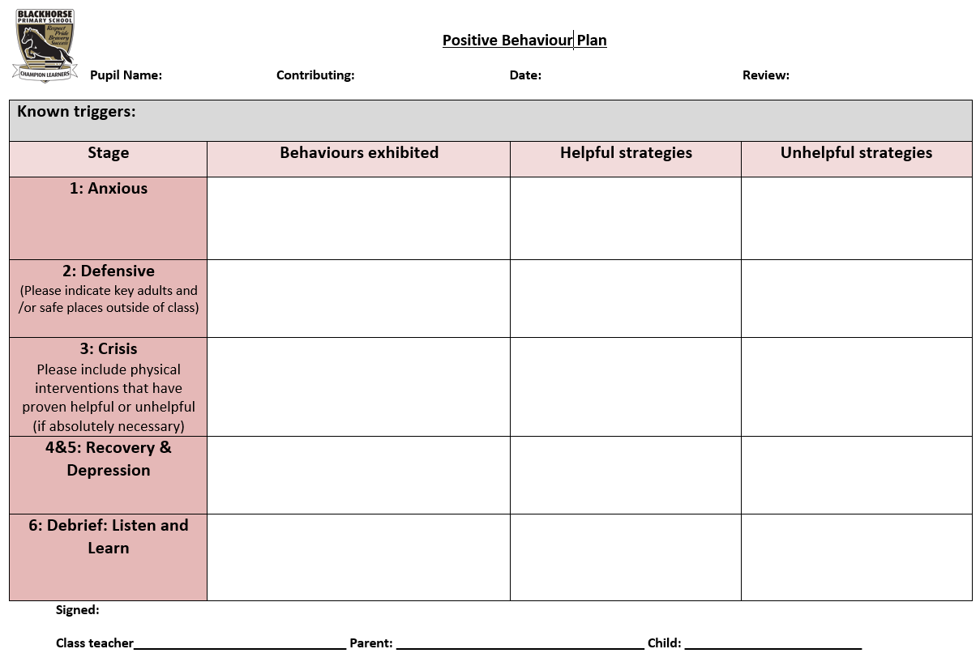

NB: Term refers to 2 small ‘termlets’
Appendix A – Exclusions Flowchart

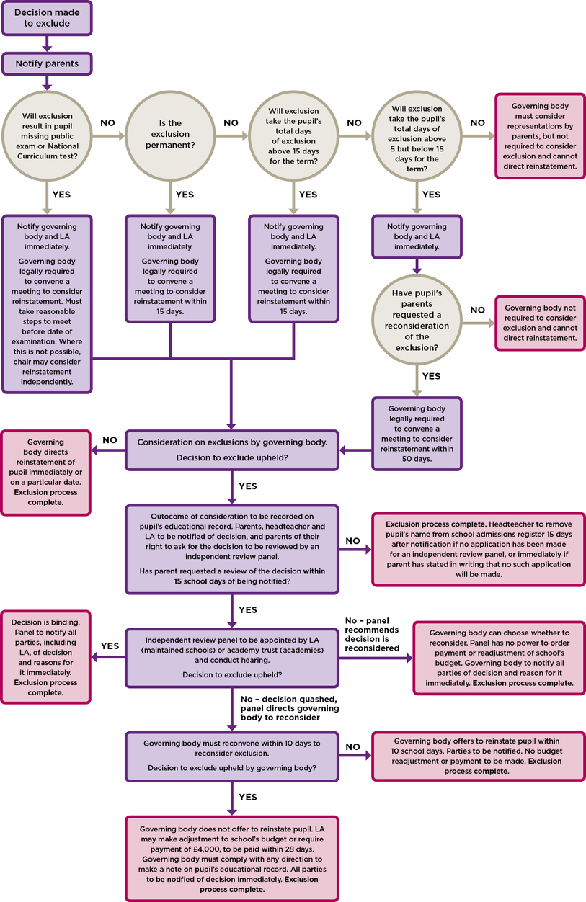

Appendix B – Alternatives to Exclusion Checklist Primary
STUDENT FOCUSED INTERVENTIONS  Managing anger/emotions/conflict resolution  Social Skills/peer relationships  Mental Health  Classroom behaviour skills  Time out card | RELATIONSHIP BUILDING INTERVENTIONS  Restorative mediation with key staff  Micro-management daily check in/debrief  Key adult support/mentoring  Peer mentor schemes
LEARNING INTERVENTIONS  Personalised learning/timetable change  SMART targets/daily positive report card  Literacy assessment  Tutor change/house change/class swap  Classroom observations  (frequency/ABC charts | ALTERNATIVE PROVISION  In school inclusion facility  Off-site provision (CLIC, Engage)  Specialist mentoring (Breakthrough, Impact)  Early intervention strategies  (school swap/intervention moves)
ASSESSMENT AND PLANNING  SAF eh  ISS/PSP/BSP with regular reviews  Planning reviewed internally through 360* or similar  Change Tracker  Academic assessment review to check progress and access to learning  EP assessment  PASS/attitudinal assessment  Speech and language assessment  Medical needs assessment | SEN STATUS  EHCP  SEN K  SAFEGUARDING CONCERNS  ART referral  SERAF  My concern  PARENTAL ENGAGEMENT  Regular contact/engagement with behaviour plan
RESPONSE TO ESCALATING BEHAVIOUR  Different day intervention  Fixed period exclusions  Internal exclusion/seclusion | SPECIALIST INTERVENTION  Referral to EPS  YOT  FYPS  CAMHS  ISS  School nurse  Social Care  GP/Paed/Medical
BEHAVIOUR DATA INTERVENTION  Patterns of negative incidents from Teachers have been addressed  The data is analysed regularly | 

Please also refer to additional guidance for schools on dealing with behaviour that challenges document

Appendix C – Alternatives to Exclusion Checklist (2)

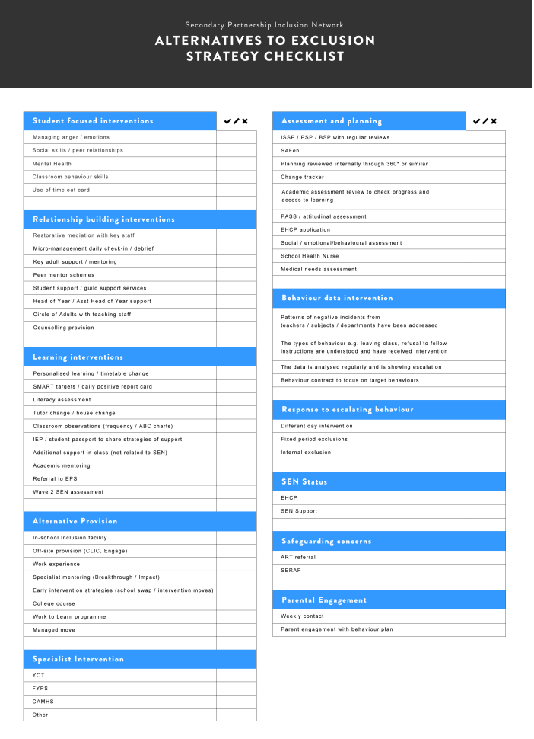

Appendix C – Headteacher’s/Principal’s Exclusion Checklist
 | Yes | No
On the balance of probabilities, did the pupil do it?

Does the incident represent a serious breach of the school behaviour policy / the final straw incident in a series of persistent breaches of the behaviour policy?

Does the pupil’s presence seriously harm the education/welfare of the pupil or others in the school community?

Is exclusion the appropriate response?
Factors to Consider
• Decision to exclude not taken in the heat of the moment
• A thorough investigation has been carried out
• Evidence has been considered in the light of policies and discrimination
• The pupil’s views have been encouraged, heard and recorded
• Mitigating circumstances and provocation (bullying etc.) have been considered
• Appropriate wider consultation has been considered

Has there been involvement from specialist teachers (SEND) or Behaviour/Inclusion Service or an Educational Psychologist?

Has a pastoral support programme been tried?

Is there an Early Help strategy/EHAP in place?
Have alternatives to exclusion been considered? See Appendix B – Alternatives to Exclusion Checklist (e.g. restorative justice, mediation, internal exclusion, school to school managed move)?

Special Considerations
Does this pupil have an Education Health Care Plan [EHCP] (statement of special educational needs)?
If so:
- Have you contacted the special needs officer?
- Has an emergency annual review been called?

Is this pupil currently a child in the care of the Local Authority?
If so:
- Have you contacted the Head of the Virtual School and Social Worker?

Is this pupil subject to Child Protection procedures or a Child In Need?
If so:
- Have you spoken to the Social Worker?

Have issues of SEN, disability, race and care been fully considered?
See separate check list for considerations around the exclusion of children with SEN/disability

Has the appropriate length of exclusion been considered?

Appendix D – Suspension and Permanent Exclusion Guidelines lined to letters
Suspension  up to and including 5 days in one term  (can be cumulative)  Model Letter 1 | Suspension  adding up to more than 5 days and up to 15 days in one term  (can be cumulative)  Model Letter 2 | Suspension  adding up to MORE THAN 15 days in one term and no more than 45 days in school year  (can be cumulative)  Model Letter 3 | PERMANENT EXCLUSION (PEX)  Model Letter 4
- Immediately inform parents/carers of type and length of exclusion and reasons for exclusion.  - Inform parents/carers of right to make representations to Gov. Body (model letter 1).  - Inform LA and record on SIMs.  - Make arrangements for setting and marking work.  - Make arrangements for a re-integration meeting that plans how future behaviour will be managed (not compulsory but good practice).  - Maintain school exclusions database in order to monitor an aggregate of suspensions.  - Report exclusions termly to Gov Body.  - Contact Inclusion Support Worker (via Pathways Learning Centre) for advice and support (not compulsory but good practice). | - Immediately inform parents/carers of type and length of exclusion and reasons for exclusion.  - Inform parents/carers of right to make representations to Gov. Body (model letter 2).  - Inform Gov. Body to arrange meetings between 6th and 50th schools days following exclusion, if parent has requested a meeting.  - Inform LA and record exclusion on SIMS within one school day.  - Make arrangements for setting and marking work for the first 5 days.  - Make arrangements for a re-integration meeting that plans how future behaviour will be managed (not compulsory but good practice).  - Ensure all required documentation is made available to Gov. Body, Parent and LA when required.  - Comply with Gov. Body’s resolution to either decline to reinstate or to reinstate either immediately or by a specific, if Governors so resolve.  - Start/Continue a EHAP and engage with external agencies and parents/carers as a preventative approach to develop an action plan. Ensure parents/carers & pupil’s views are included in action plans and reviews (not compulsory but good practice).  - Continue working with Inclusion Support Worker (via Pathways Learning Centre) and possible referral to High Risk Group (HRG).  For all suspension over 5 days  - Arrange suitable full time education from the 6th day  - Inform parents/carers of arrangements for education during the exclusion | - Immediately inform parents/carers of type and length of exclusion, and reasons for exclusion.  - Inform parents/carers of right to make representations to Gov. Body(Model letter 3).  - Inform Gov. Body to arrange meeting on or before 15th school day – statutory meeting.  - Inform LA (and Home LA if not S. Glos) responsible officer for exclusions via email.  - Make arrangements for setting and marking work for the first 5 days.  - Make arrangements for a re-integration meeting that plans how future behaviour will be managed (not compulsory but good practice).  - Ensure all required documentation is made available to Gov. Body, parent/carer and LA.  - Comply with Gov. Body’s resolution to either decline to reinstate or to reinstate either immediately or by a specific, if Governors so resolve.  - Start/Continue a EHAP and engage with external agencies as a preventative approach and parents/carers as a preventative approach to develop an action plan. Ensure parents/carers & pupil’s views are included in action plans and reviews (not compulsory but good practice).  - Continue working with Inclusion Support Worker (via Pathways Learning Centre) and ENSURE there is a referral to High Risk Group (HRG).  For all suspension over 5 days  - Arrange suitable full time education from the 6th day  - Inform parents/carers of arrangements for education during the exclusion | - Immediately inform parents/carers of type of exclusion and reasons for exclusion.  - Inform parents/carers of right to make representations to Governing Body (Model letter 4).  - Inform Governing Body to arrange meeting on or before 15th school days.  - Inform LA (and “Home” LA if not S Glos) responsible officer for exclusions via email and phone to inform LA of the PEX and that information has been uploaded via SOFIE.  - Complete a referral to Pathways Learning Centre (if pupil lives in South Glos) without delay to make the appropriate provision from the 6th day. Information to be sent secure (e.g using SOFIE) and a copy to be sent to Exclusions and Licencing team (SOFIE/Local Authority/Ad Hoc/Exclusions and licensing) When notifying PLC, please check with them that the information has been received by telephone.  - Make arrangements for setting and marking work for the first 5 days (If fixed term made permanent start counting again from the date the exclusion is made permanent).  - Ensure all required documentation made available (5 school days before the hearing) to Governing Body, parent/carer and LA, using secure communication.  - Comply with Gov. Body’s resolution to either decline to reinstate or to reinstate either immediately or by a specific, if Governors so resolve.  - Maintain the pupil on the school roll until the parental right to ask for the decision to be reviewed (para. 79 - 82) is exhausted.
Notes: Any reference to page numbers or paragraphs refers to Suspension and Permanent Exclusion from maintained schools, academies and pupil referral units in England, including pupil movement
- Letters may need to be translated into other languages where the parents/carers first language is not English.
- For all suspensions – if the child loses the opportunity to take a public examination or National Curriculum Test the Governing Body MUST be informed.(Para’s 40, 49, 55, 57 and 62 and Annex A Flowchart of DfE Exclusion Guidance Sept 2017 and Annex B A non-statutory guide for head teachers.)
- Lunchtime exclusion counts as half day.
- A child in the care of the LA (or in voluntary care) should not be excluded without considering alternative options for supporting the pupil and discussion with the LA to ensure suitable alternative full –time provision from Day 1. (summary and Para’s 21, 23-25, 48, 50 and Annex B A non-statutory guide for head teachers DfE Exclusion Guidance Sept 2017).
- At all stages of the process, schools should consider the range of interventions available to meet the behavioural needs of the pupil e.g. EHAP. Inclusion/Behaviour Support, EP.
- Excluded pupils should be enabled and encouraged to participate at all stages of the exclusion process, taking into account their age and understanding.
- Pupils aged 18 or over have the right to represent themselves instead of parent/carer.
- Any decision to exclude must be made in line with the principals of administrative law i.e. that it is lawful, rational, reasonable, fair and proportionate.
- Governors should not interpret a parent’s acceptance of full-time education off-site as signalling agreement with the Headteacher’s decision to exclude.

Appendix E Model letter 1 – Suspension (up to 5 days/lunchtime exclusion)
From the Headteacher of a school notifying a parent of:
- a single suspension of 5 school days or fewer and where a public examination is not missed
- a suspension which does not take the total of fixed period exclusions to more than 5 in one term;
- a lunchtime suspension. (Parts 4 - 6 DfE guidance 2022)
(Where a school’s academic year consists of more than 3 terms, then a reference to ‘term’ means the period falling between: 31 December to Easter Monday; Easter Monday to 31 July; or 31 July to 31 December.)
Dear [Parent's Name]
I am writing to inform you of my decision to exclude [Child's Name] for a fixed period of [specify period]. This means that he/she will not be allowed in school for this period. The exclusion begins/began on [date] and ends on [date].
I realise that this exclusion may well be upsetting for you and your family, but the decision to exclude [Child's Name] has not been taken lightly. [Child's Name] has been excluded for this fixed period because [reason for exclusion].
You have the right to make representations about this decision to the governing body. [Child's Name] may also be involved in making representations [Explain how this may happen]. If you wish to make representations please contact [Detail how parent needs to make representations – where and to whom e.g. letter, email or telephone contact to governors/clerk, giving number, email or postal address?]. Whilst the governing body has no power to direct reinstatement and is not required to arrange a meeting with you, they must consider any representations you make and may place a note of their findings on your child's educational record.
[For pupils of compulsory school age only]
You are legally required to ensure that your child is not present in a public place in school hours during this exclusion on [specify dates] unless there is reasonable justification for this. I must advise you that you may be given a penalty notice or prosecuted if your child is present in a public place during school hours on the specified dates and you fail to provide reasonable justification for this.
[For pupils of compulsory school age only]
We will set work for [Child's Name] to be completed during the period of his/her exclusion. [Detail the arrangements for this]. Please ensure that work set by the school is completed and returned to us promptly for marking. [If alternative provision is being arranged during an exclusion of 5 days or less the letter should provide details – when/where it will take place and who to report to on the first day.]

You should also be aware that if you think the exclusion relates to discrimination you can make a claim, to the First Tier Tribunal for disability discrimination (http://www.justice.gov.uk/tribunals/send/appeals) or to a County Court for other forms of discrimination.

The following information may be helpful:
- Statutory guidance on exclusion: http://www.education.gov.uk/schools/pupilsupport/behaviour/exclusion
- The Children's Legal Centre: they aim to provide free legal advice and information to parents on state education matters. They can be contacted on 0808 802 0008 or on http://www.childrenslegalcentre.com/. The advice line is open from 8am to 8pm Monday to Friday, except Bank Holidays and 24th December to the 1st January.
- Include other relevant links for example social care, Ethnic Minority & Traveller Achievement Service or the local parent partnership (www.parentpartnership.org.uk).

[Child's Name]'s exclusion expires on [date] and we expect [Child's Name] to be back in school on [date] at [time]. [There is no requirement to hold a reintegration meeting but it would be good practice to do so – ‘Schools should have a strategy for reintegrating pupils that return to school following a fixed period exclusion, and for managing their future behaviour.’; detail the arrangements for the pupil’s return to school].
Yours sincerely

[Name]
Headteacher

Appendix F – Model Letter 2 – Suspension (6-15 days in one term)
From Headteacher notifying parent of a single fixed period exclusion of between 6 and 15 days in length or one which would take the total of exclusions in one term to more than 5 and up to and including 15 school days (Parts 4 - 6 DfE guidance 2022)

(Where a school’s academic year consists of more than 3 terms, then a reference to ‘term’ means the period falling between: 31 December to Easter Monday; Easter Monday to 31 July; or 31 July to 31 December.)
Dear [Parent's Name]

I am writing to inform you of my decision to exclude [Child's Name] for a fixed period of [specify period/number of days]. This means that [Child's Name] will not be allowed in school for this period. The exclusion start date is [date] and the end date is [date]. Your child should return to school on [date].

I realise that this exclusion may well be upsetting for you and your family, but the decision to exclude [Child's Name] has not been taken lightly. [Child's Name] has been excluded for this fixed period because [specify reasons for exclusion].

If requested to do so by parents, the governing body must consider the reinstatement of an excluded pupil within 50 school days of receiving notice of the exclusion if a pupil would be excluded from school for more than five school days, but not more than 15, in a single term.
[insert date here — no later than 15 school days from the date the governing body is notified].

[Maintained schools only]
You have the right to attend the meeting, be represented (at your own expense) and also to bring a friend. The head teacher and a representative of the local authority will also be invited to attend and to make representations. [Child's Name] may also be involved in making representations. [Explain how this may happen]

If you wish to request the governing body meet to consider this exclusion please contact [Detail how parent needs to make representations – where and to whom e.g. letter, email or telephone contact to governors/clerk, giving number, email or postal address?].

The governing body will make reasonable endeavours to arrange the meeting for a date and time that is convenient to all parties, but in compliance with the relevant statutory time limit of 50 school days from receiving notice of the exclusion. The governing body will circulate any written evidence and information, including a list of those who will be present, to all parties at least five school days in advance of the meeting. You will, whether you choose to make representations or not, be notified by the Clerk to the governing body of the time, date and location of the meeting. Please let us know if you have a disability or special needs which would affect your ability to attend the meeting or to make representations. Also, please inform [Clerk] if it would be helpful for you to have an interpreter present at the meeting.
[For pupils of compulsory school age only]
You are legally required to ensure that your child is not present in a public place in school hours during this exclusion on [specify dates] unless there is reasonable justification for this. I must advise you that you may be given a penalty notice or prosecuted if your child is present in a public place during school hours on the specified dates and you fail to provide reasonable justification for this.
[For pupils of compulsory school age only]
We will set work for [Child's Name] during the [first 5 or specify other number as appropriate] school days of his/her exclusion [Detail the arrangements for this]. Please ensure that work set by the school is completed and returned to us promptly for marking. [If alternative provision is being arranged before day six the letter should provide details of this including when/where it will take place and who to report to on the first day.]
[If the individual exclusion is for more than 5 days - for pupils of compulsory school age only] but provision does not have to be arranged by either the school or local authority for pupils in the final year of compulsory education who do not have any further public examinations to sit.
If alternative provision is being arranged then the following information must be included with this notice where it can reasonably be found out within the timescale; if this information on alternative provision is not reasonably ascertainable by the end of the afternoon session it may be provided in a subsequent notice, but it must be provided without delay and no later than 48 hours before the provision is due to start.
For a fixed period exclusion of more than five school days, the governing body must arrange suitable full-time education for any pupil of compulsory school age. From the sixth school day of the exclusion onwards — i.e. from [specify the date] until the expiry of the exclusion South Gloucestershire Pupil Referral Unit will provide suitable full-time education. [Detail the arrangements for this if known at the time of writing; if not known say that the arrangements will be notified shortly by a further letter (without delay and no later than 48 hours before the provision is due to start) - e.g. including the start date for any provision of full-time education that has been arranged for the pupil during the exclusion; the start and finish times of any such provision, including the times for morning and afternoon sessions where relevant; the address at which the provision will take place; and any information required by the pupil to identify the person he / she should report to on the first day.] I have forwarded your details to the Pupil referral Unit and they will be in touch shortly. They can be contacted on 01454 868600.
You should also be aware that if you think the exclusion relates to discrimination you can make a claim, to the First Tier Tribunal for disability discrimination (http://www.justice.gov.uk/tribunals/send/appeals) or to a County Court for other forms of discrimination.
The following information may be helpful:
- Statutory guidance on exclusion: http://www.education.gov.uk/schools/pupilsupport/behaviour/exclusion
- The Children's Legal Centre: they aim to provide free legal advice and information to parents on state education matters. They can be contacted on 0808 802 0008 or on http://www.childrenslegalcentre.com/. The advice line is open from 8am to 8pm Monday to Friday, except Bank Holidays and 24th December to the 1st January.
- Include other relevant links for example social care, Ethnic Minority & Traveller Achievement Service or the local parent partnership (www.parentpartnership.org.uk).

[Child's Name]'s exclusion expires on [date] and we expect [Child's Name] to be back in school on [date] at [time]. [There is no requirement to hold a reintegration meeting but it would be good practice to do so – ‘Schools should have a strategy for reintegrating pupils that return to school following a fixed period exclusion, and for managing their future behaviour.’; detail the arrangements for the pupil’s return to school].
Yours sincerely
[Name]
Headteacher

Appendix G – Model Letter 3 – Suspension (15 days or more in one term)
From Headteacher notifying parent of a suspension of more than 15 school days in total in one term (or which brings the pupil’s total number of days of suspension to more than 15 in one term). (Parts 4 - 6 DfE guidance 2022)

(Where a school’s academic year consists of more than 3 terms, then a reference to ‘term’ means the period falling between: 31 December to Easter Monday; Easter Monday to 31 July; or 31 July to 31 December.)
Dear [Parent's Name]
I am writing to inform you of my decision to exclude [Child's Name] for a fixed period of [specify period/number of days]. This means that [Child's Name] will not be allowed in school for this period. The suspension start date is [date] and the end date is [date]. Your child should return to school on [date].
I realise that this suspension may well be upsetting for you and your family, but the decision to exclude [Child's Name] has not been taken lightly. [Child's Name] has been excluded for this fixed period because [specify reasons for suspension].
The governing body must consider the reinstatement of an suspended pupil within 15 school days of receiving notice of the suspension if it is suspension which would bring the pupil's total number of school days of suspension to more than 15 in a term. The latest date on which the governing body can meet is [insert date here — no later than 15 school days from the date the governing body is notified].

[Maintained schools only]
You have the right to attend the meeting, be represented (at your own expense) and also to bring a friend. The head teacher and a representative of the local authority will also be invited to attend and to make representations. [Child's Name] may also be involved in making representations. [Explain how this may happen]
If you wish to make representations please contact [Detail how parent needs to make representations – where and to whom e.g. letter, email or telephone contact to governors/clerk, giving number, email or postal address?].

The governing body will make reasonable endeavours to arrange the meeting for a date and time that is convenient to all parties, but in compliance with the relevant statutory time limit of 15 school days from receiving notice of the suspension. The governing body will circulate any written evidence and information, including a list of those who will be present, to all parties at least five school days in advance of the meeting. You will, whether you choose to make representations or not, be notified by the Clerk to the governing body of the time, date and location of the meeting. Please let us know if you have a disability or special needs which would affect your ability to attend the meeting or to make representations. Also, please inform [Clerk] if it would be helpful for you to have an interpreter present at the meeting.
[For pupils of compulsory school age only]
You are legally required to ensure that your child is not present in a public place in school hours during this suspension on [specify dates] unless there is reasonable justification for this. I must advise you that you may be given a penalty notice or prosecuted if your child is present in a public place during school hours on the specified dates and you fail to provide reasonable justification for this.
[For pupils of compulsory school age only]
We will set work for [Child's Name] during the [first 5 or specify other number as appropriate] school days of his/her suspension [Detail the arrangements for this]. Please ensure that work set by the school is completed and returned to us promptly for marking. [If alternative provision is being arranged before day six the letter should provide details of this including when/where it will take place and who to report to on the first day.]
[If the individual suspension is for more than 5 days - for pupils of compulsory school age only] but provision does not have to be arranged by either the school or local authority for pupils in the final year of compulsory education who do not have any further public examinations to sit.
If alternative provision is being arranged then the following information must be included with this notice where it can reasonably be found out within the timescale; if this information on alternative provision is not reasonably ascertainable by the end of the afternoon session it may be provided in a subsequent notice, but it must be provided without delay and no later than 48 hours before the provision is due to start.
For a suspension of more than five school days, the governing body must arrange suitable full-time education for any pupil of compulsory school age. From the sixth school day of the suspension onwards — i.e. from [specify the date] until the expiry of the suspension South Gloucestershire Pupil Referral Unit (Pathways Learning Centre ) will provide suitable full-time education. [Detail the arrangements for this if known at the time of writing; if not known say that the arrangements will be notified shortly by a further letter (without delay and no later than 48 hours before the provision is due to start) - e.g. including the start date for any provision of full-time education that has been arranged for the pupil during the suspension; the start and finish times of any such provision, including the times for morning and afternoon sessions where relevant; the address at which the provision will take place; and any information required by the pupil to identify the person he / she should report to on the first day.] I have forwarded your details to the Pupil Referral Unit (Pathways Learning Centre) and they will be in touch shortly. They can be contacted on 01454 862630
You should also be aware that if you think the suspension relates to discrimination you can make a claim, to the First Tier Tribunal for disability discrimination (http://www.justice.gov.uk/tribunals/send/appeals) or to a County Court for other forms of discrimination.
The following information may be helpful:
- Statutory guidance on suspension: https://www.gov.uk/topic/schools-colleges-childrens-services/school-behaviour-attendance
- The Children's Legal Centre: they aim to provide free legal advice and information to parents on state education matters. They can be contacted on 0808 802 0008 or on http://www.childrenslegalcentre.com/. The advice line is open from 8am to 8pm Monday to Friday, except Bank Holidays and 24th December to the 1st January.
- Include other relevant links for example social care, Ethnic Minority & Traveller Achievement Service or the local parent partnership (www.parentpartnership.org.uk).

[Child's Name]'s suspension expires on [date] and we expect [Child's Name] to be back in school on [date] at [time]. [There is no requirement to hold a reintegration meeting but it would be good practice to do so – ‘Schools should have a strategy for reintegrating pupils that return to school following a suspension, and for managing their future behaviour.’; detail the arrangements for the pupil’s return to school].
Yours sincerely
[Name]
Headteacher

Appendix H – Model Letter 4 – Permanent Exclusion
From the Headteacher of a school notifying the parent(s) of a pupil's permanent exclusion. (Parts 4 - 6 DfE guidance 2022)
Dear [Parent's Name]
I regret to inform you of my decision to permanently exclude [Child's Name] with effect from [date]. This means that [Child's Name] will not be allowed in this school unless he/she is reinstated by the governing body.
I realise that this exclusion may well be upsetting for you and your family, but the decision to permanently exclude [Child's Name] has not been taken lightly. [Child's Name] has been excluded because [reasons for the exclusion — include any other relevant previous history].

As this is a permanent exclusion the governing body has a legal requirement to consider the exclusion.

[Maintained schools only]
You have the right to attend the meeting, be represented (at your own expense) and also to bring a friend. The head teacher and a representative of the local authority will also be invited to attend and to make representations. [Child's Name] may also be involved in making representations. [Explain how this may happen]

If you wish to make representations please contact [Detail how parent needs to make representations – where and to whom e.g. letter, email or telephone contact to governors/clerk, giving number, email or postal address?].

The governing body will circulate any written evidence and information, including a list of those who will be present, to all parties at least five school days in advance of the meeting. You will, whether you choose to make representations or not, be notified by the Clerk to the governing body of the time, date and location of the meeting. Please let us know if you have a disability or special needs which would affect your ability to attend the meeting or to make representations. Also, please inform [Clerk] if it would be helpful for you to have an interpreter present at the meeting.

[For pupils of compulsory school age only]
You are legally required to ensure that your child is not present in a public place in school hours during this exclusion on [specify dates] unless there is reasonable justification for this. I must advise you that you may be given a penalty notice or prosecuted if your child is present in a public place during school hours on the specified dates and you fail to provide reasonable justification for this.
[For pupils of compulsory school age only]
Alternative arrangements for [Child's Name]'s education to continue will be made.
For the first five school days of the exclusion we will set work for [Child's Name] to be completed during the period of his/her exclusion. [Detail the arrangements for this]. Please ensure that work set by the school is completed and returned to us promptly for marking. [If alternative provision is being arranged before day six the letter should provide details of this including when/where it will take place and who to report to on the first day.]
[Where pupil lives in South Gloucestershire - for pupils of compulsory school age only] but provision does not have to be arranged by either the school or local authority for pupils in the final year of compulsory education who do not have any further public examinations to sit.
For a permanent exclusion, the Local Authority must arrange suitable full-time education for any pupil of compulsory school age from the sixth school day of the exclusion onwards — i.e. from [specify the date] until the expiry of the exclusion. South Gloucestershire Pupil Referral Unit (Pathways Learning Centre) will provide suitable full-time education. [Detail the arrangements for this if known at the time of writing; if not known state that the arrangements will be notified by a further letter (without delay and no later than 48 hours before the provision is due to start) - e.g. the start date for any provision of full-time education that has been arranged for the pupil during the exclusion; the start and finish times of any such provision, including the times for morning and afternoon sessions where relevant; the address at which the provision will take place; and any information required by the pupil to identify the person he / she should report to on the first day.] I have forwarded your details to the Pupil Referral Unit (Pathways Learning Centre) and they will be in touch shortly. They can be contacted on 01454 862630.
[Where pupil lives in a local authority other than the excluding school's local authority - For pupils of compulsory school age only]
For a permanent exclusion, the Local Authority must arrange suitable full-time education for any pupil of compulsory school age from the sixth school day of the exclusion onwards — i.e. from [specify the date] until the expiry of the exclusion. I have also today informed [name of officer] at [name of local authority] (e.g. Clare Dudley, Bristol LA) of your child's exclusion and they will be in touch with you about arrangements for [his/her] education from the sixth school day of exclusion. You can contact them at [give contact details].
You should also be aware that if you think the exclusion relates to discrimination you can make a claim, to the First Tier Tribunal for disability discrimination (http://www.justice.gov.uk/tribunals/send/appeals ) or to a County Court for other forms of discrimination.
The following information may be helpful:
- Statutory guidance on exclusion: http://www.education.gov.uk/schools/pupilsupport/behaviour/exclusion
- The Children's Legal Centre: they aim to provide free legal advice and information to parents on state education matters. They can be contacted on 0808 802 0008 or on http://www.childrenslegalcentre.com/. The advice line is open from 8am to 8pm Monday to Friday, except Bank Holidays and 24th December to the 1st January.
- [Include other relevant links for example social care, Ethnic Minority & Traveller Achievement Service or the local parent partnership (www.parentpartnership.org.uk).]
Yours sincerely
[Name]
Headteacher

Appendix I – Model Letter 5 - From the Governing Body of a school notifying a parent of its decision not to reinstate a pupil
From the Governing Body of a school notifying a parent of its decision not to reinstate a pupil (i.e. to uphold the head’s decision to permanently exclude the pupil). (Part 6 DfE guidance 2022)

(Please forward a copy of this letter to the LA; and also to Neil Young (Democratic Services) for information)

Dear [Parent's Name]

The meeting of the Governing Body at [Name of school] on [date] considered the decision by [Head’s Name] to permanently exclude your [son/daughter Name]. The governing body, after carefully considering the representations made and all the available evidence, has decided to uphold the permanent exclusion of [Name of Pupil].

The reasons for the governing body's decision are [Insert reasons in sufficient detail to enable all parties to understand why the decision was made].
……………………………

You have the right to ask for this decision to be reviewed by an independent review panel. If you wish to make an application for a review of the Governing Body’s decision you will need to do so no later than [day and date – i.e. 15 school days plus 2 school days from the date of the letter when posted by 1st class post; ‘Notice is deemed to have been given on the same day if it is delivered directly, or on the second working day after posting if it is sent by first class mail’.]. If you make an application for a review after this date it will be rejected by the local authority.

The application should be made to
Neil Young, Principal Democratic Service Officer
South Gloucestershire Council
Chief Executive & Corporate Resources Department
PO Box 1953
Bristol
BS37 0DB

Please inform Neil Young if you have a disability or special needs which would affect your ability to attend the hearing or if it would be helpful for you to have an interpreter present at the hearing. [For an Academy that does not trade with Legal Services, details and address of own provider which the parent should contact if they wish to request an independent review, should be inserted in place of Neil Young.]

The role of the independent review panel is to review the Governing Body’s decision not to reinstate a permanently excluded pupil. The panel can decide to:
- Uphold the exclusion decision
- Recommend that the Governing Body reconsiders their decision; or
- Quash the decision and direct that the Governing Body considers the exclusion again

Any application should set out the grounds on which it is being made and that, where appropriate, this should include a reference to how the pupil’s special educational needs are considered to be relevant to the exclusion. You have the right to require the Local Authority to appoint a SEN expert to attend the review regardless of whether your child has recognised special education needs; there would be no cost to you for this. The role of the SEN expert is to provide impartial advice to the independent review panel on how special educational needs might be relevant to the exclusion. You must make it clear in your application for a review whether you wish for a SEN expert to be appointed.

You may, at your own expense, appoint someone to make written and/or oral representations to the independent review panel. You may also bring a friend to the review.

In addition to your right to apply for an independent review panel, if you believe that the exclusion has occurred as result of discrimination then you may make a claim under the Equality Act 2010 to the First-tier Tribunal (Special Educational Needs and Disability) in the case of disability discrimination, or the County Court in the case of other forms of discrimination. A claim of discrimination should be lodged within six months of the date on which the alleged discrimination took place e.g. the day on which [Name of Pupil] was excluded.

The following sources of free and impartial information will allow you to make an informed decision on whether and how to seek a review of the Governing Body’s decision:
- Department for Education guidance - Exclusion from maintained schools, academies and pupil referral units in England https://www.gov.uk/government/uploads/system/uploads/attachment_data/file/630073/Exclusion_from_maintained_schools__academies_and_pupil_referral_units_guidance.pdf
- Guidance on making a claim of discrimination to the First-tier tribunal – http://www.justice.gov.uk/tribunals/send/appeals
- the Coram Children’s Legal Centre – www.childrenslegalcentre.com , they can be contacted on 0808 802 0008
- [Also include where considered relevant by governing body – contact details for Traveller Education Services (EMTAS) or Supportive Parents for SEN pupils]

If you do not intend to make an application for a review of this decision you may confirm this in writing to me, but please note, once the Governing Body has received your decision not to apply for a review the head teacher will remove your child’s name from the school register.

Yours sincerely

[Name]
Chair/Clerk to the Governing Body

